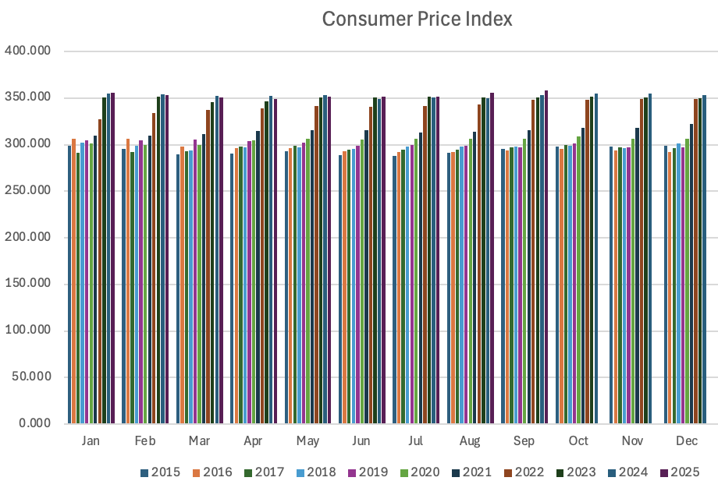
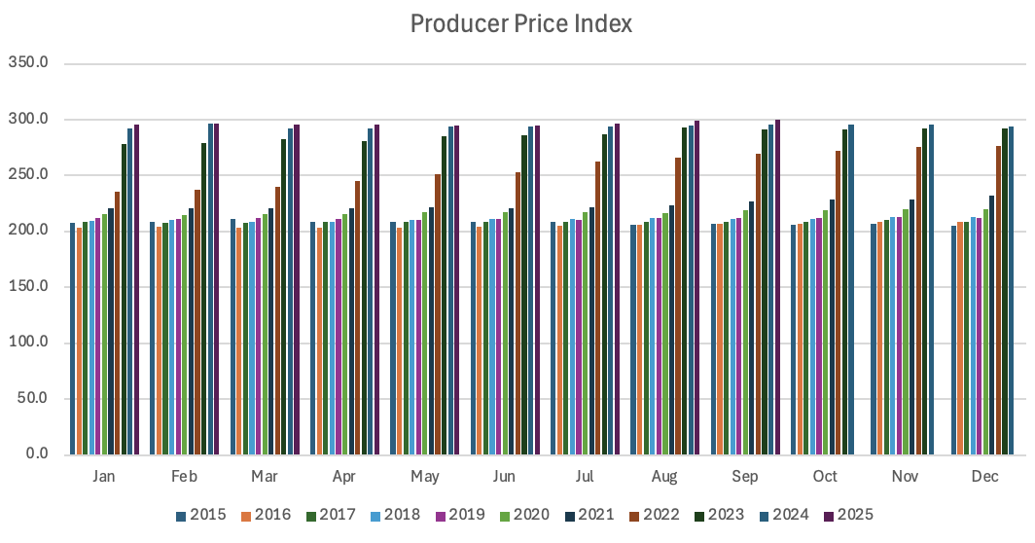
The above bar graphs show how both CPI and PPI have gone up sense 2015. It also shows how CPI and PPI are not related to what month it is. Lastly, this shows PPI catching CPI in the last couple of years.

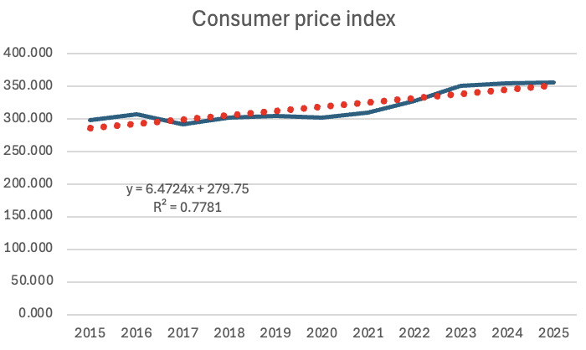
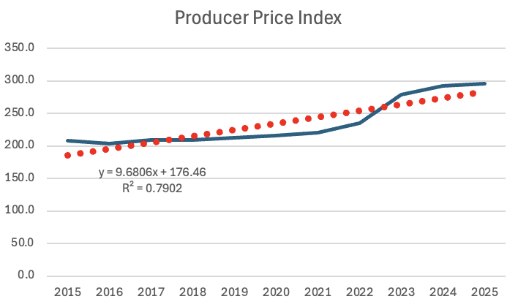
The above line graphs show the growth of CPI and PPI over the last 10 years. The equations show how PPI has grown quicker over the past decade.

